**App Trader Final Report**

**Sister Wives**

Rene Entremont, Bradley Gregory, Jared Smith, Hunter Fogg

Here are some general recommendations about the price range, genre, content rating, and any other app characteristics that we believe the company should target.

Price range 0 - $2.50

Genre - Games

Content rating - Everyone, 4+

Rating - 4.25 or higher

Reviews - high number of reviews

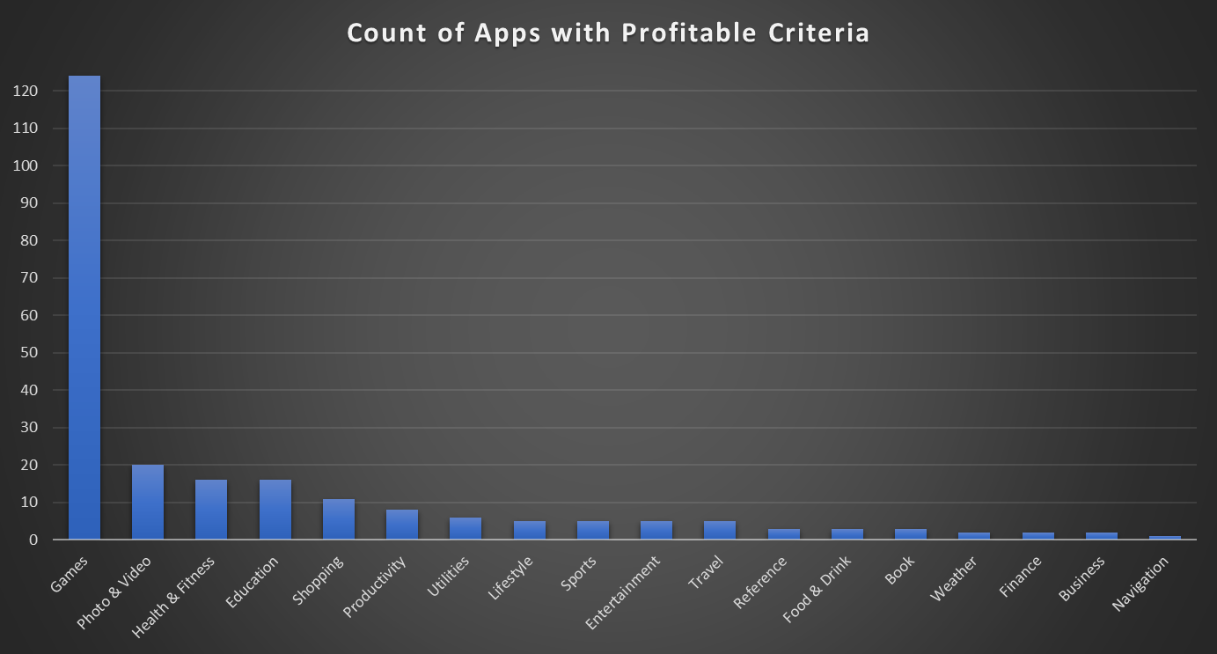

Based on the apps with profitable criteria, we determined Games to be the most marketable genre so that is where we concentrated our efforts moving forward.

**Top 10 List of the apps that App Trader should buy based on profitability/return on investment as the sole priority**.

1. Geometry Dash Lite
2. Solitaire
3. Fruit Ninja Classic
4. Fruit Ninja®
5. Angry Birds Rio
6. Flow Free
7. Traffic Racer
8. Candy Crush Saga
9. Angry Birds Star Wars
10. Sonic Dash

We came to this conclusion by using a variety of filters to return the top ten games that we believe App Trader should buy. We filtered games available on both the app store and the play store due to the increased opportunity in marketing, advertisements, and/or microtransactions. We filtered the price between $0 and $2.50 as the purchase price will be cheapest at $25,000. We filtered the content rating to Everyone and 4+ to have the largest possible consumer base. We filtered ratings to greater than 4.25 to maximize profitability (BASED ON ASSUMPTION 2.C). We filtered the review count to greater than 8000 to exclude outlier reviews that can significantly affect the rating. More reviews signifies more reliable ratings due to increased sample size. The games returned will be sound purchases as the data tells us they will return maximum profit based on our given assumptions.

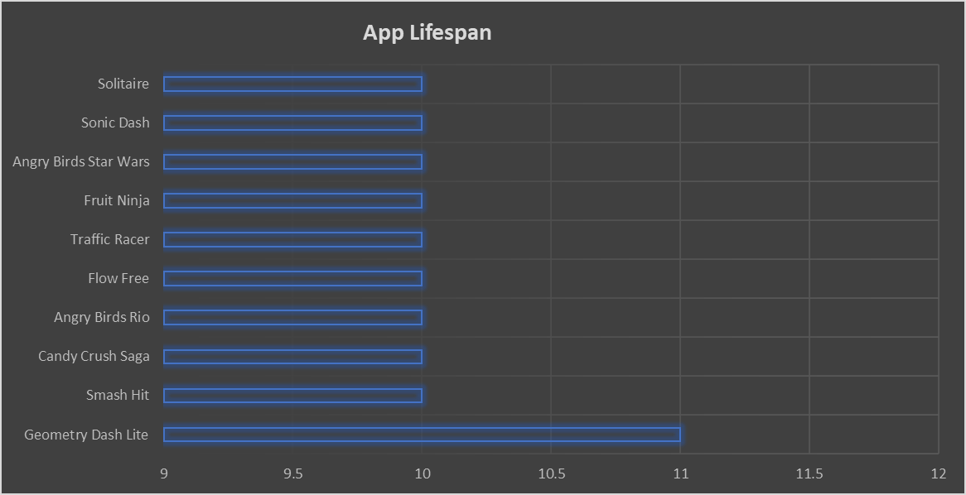

**Top 4 list of the apps that App Trader should buy that are profitable but that also are thematically appropriate for the upcoming Fourth of July themed campaign.**

1. "Athletics 2: Summer Sports - Free"
2. “Boom Beach”
3. "Ketchapp Summer Sports"
4. “Roadside America”

* Our Top 3 were chosen based on the same criteria as above, using Games as our genre. These apps do not have >8000 reviews, however they are more appropriate than our original top ten with the upcoming Fourth of July themed campaign.
* Our 4th we chose based on wanting to include at least one app that would cater to people's desire to travel during the Fourth of July holiday.

